Phase 5 - Tools
I’ve Create 4 Tools for the Banking Agent :

- RAG as a Tool – RAG built in Phase 4 is changed as tool
- Calculator – For all calculations
- Search Api – To search internet and get response for User Query.
- Supabase Db for Transactional Data.

Prompt:

“”” Choose tools automatically when needed.
Use calculator for arithmetic and amount calculations.
Use Supabase tools for customer, loan, branch, and transaction data.
Use search_api to search internet and get response for User Query..
Use rag_retrieval for internal banking document context first.”””

Tool Failures:

Failure 1:
- The Supabase DB didn’t return any values. Because the Roles are not sent to Supabase correctly
- The FD rates need to be fetched form RAG with internal Banking documents first but it went directly to Search Api
- Calculator Tool was not used for calculations

Screenshots of Failures:
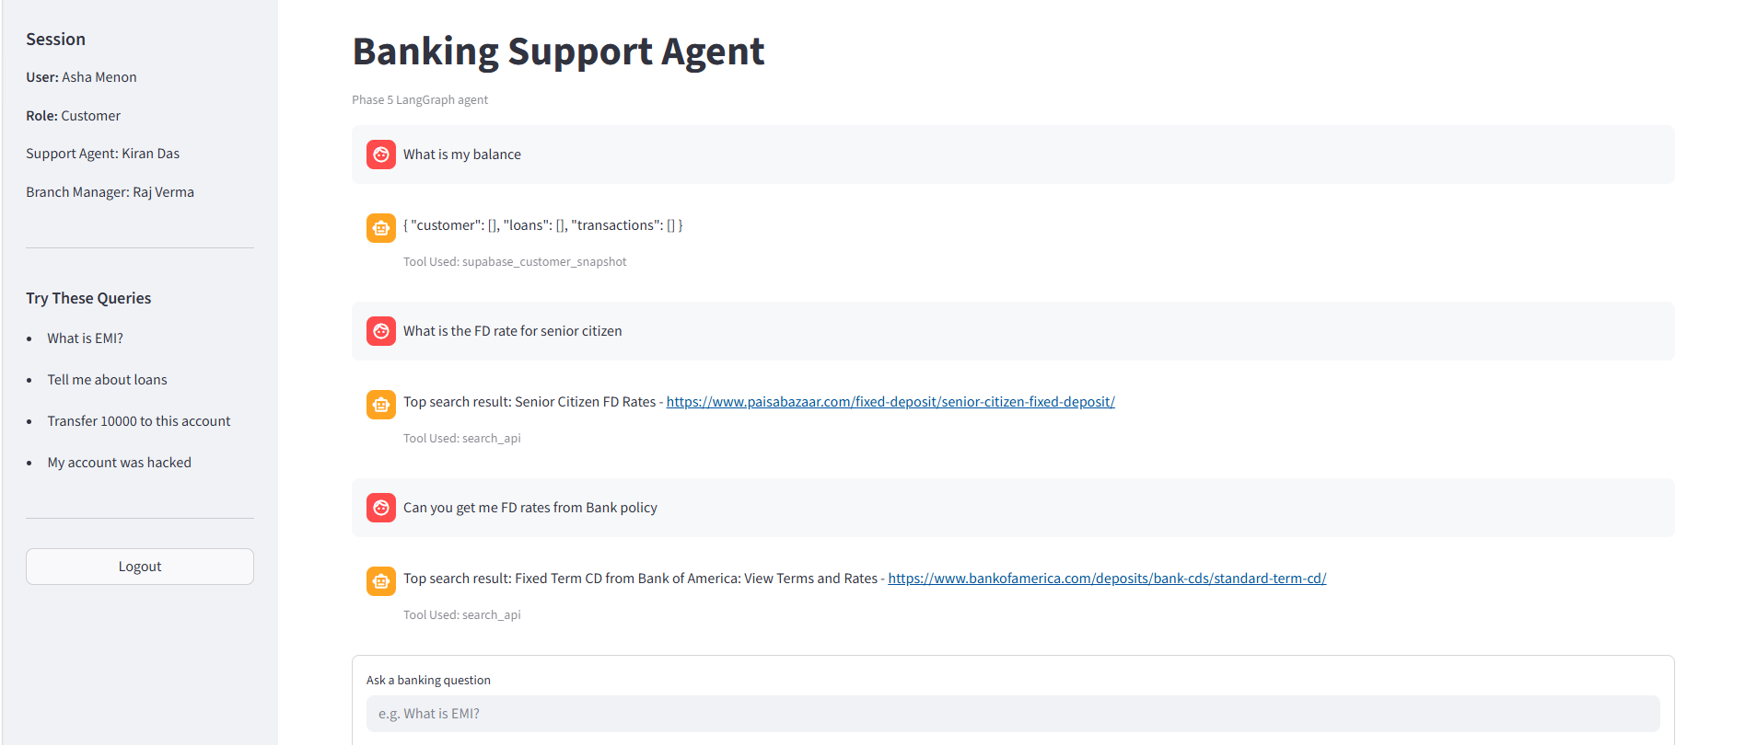

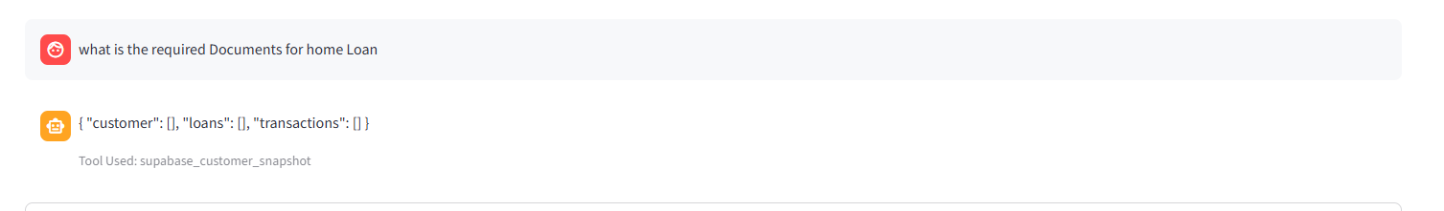

Failure 2:

Changes made:
- I change the Rules to Fetch RAG first and when results not found use Search API.
- Asked to use Calculator for math operations
- Set up RLS for Supabase
Failures:
- Only Numeric expressions were redirected to Calculator (like 4+5). Word problems were not handled.
- Roles Set but data was not fetched.
- When Data not in RAG, it didn’t use Search API to Get required details.
Screenshots of Failures:
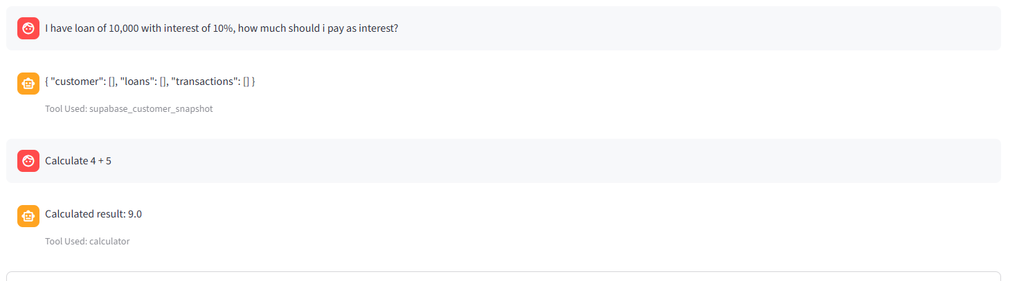

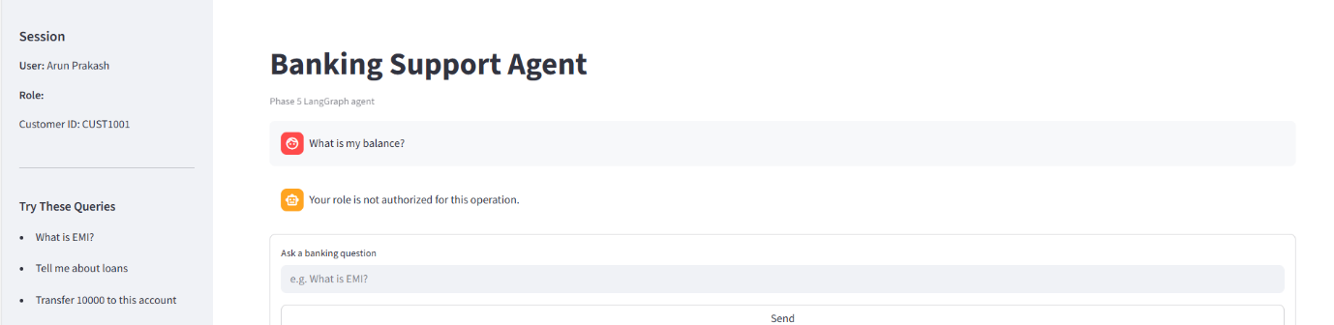

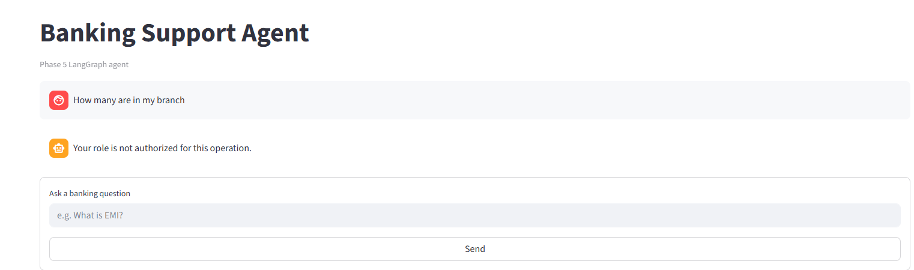

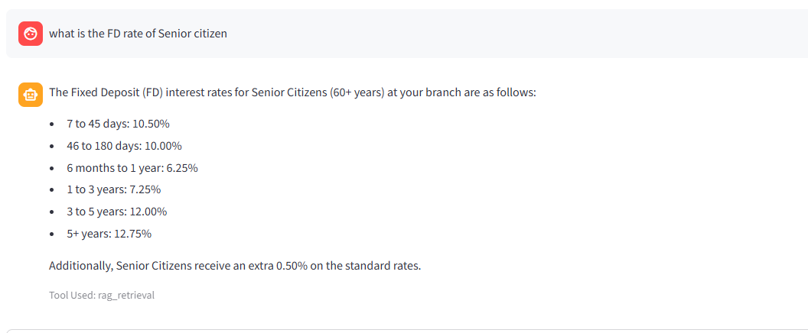
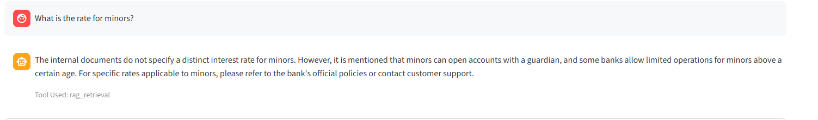

Failure 3:
New fallback behaviour to Call Search API:
- RAG returns no matches
- or confidence_score < 0.6
- or the retrieved chunks do not contain the key terms from the user query
Now the RAG Tool is used for retrieval, when not found Search Api is used.

Similarly the Calculator tool, when pass 10% the calculation fails. Since it not eliminating % during calculation.
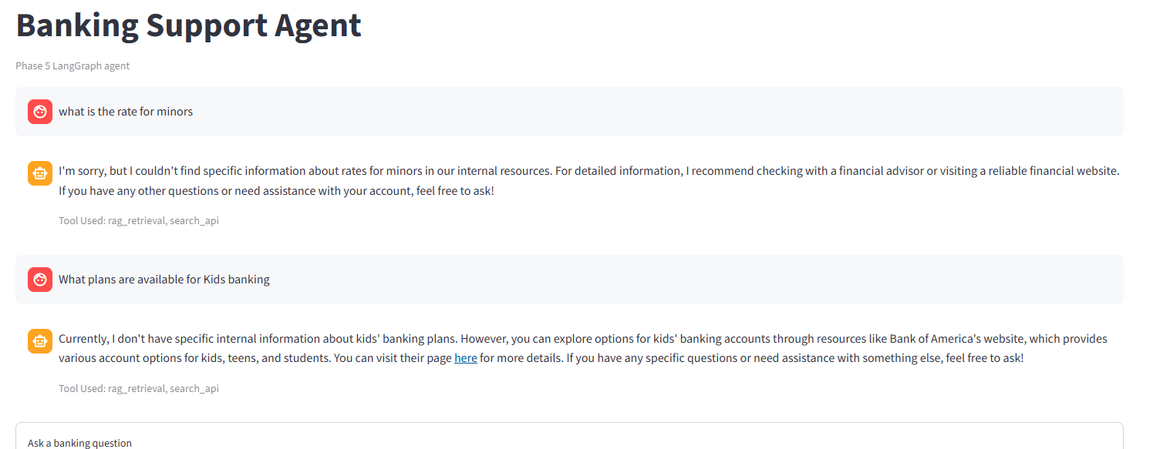
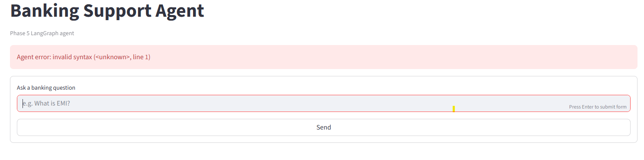

Final Prompt for Tool Calling Logic:

“””Choose tools automatically when needed.
Use calculator for arithmetic and amount calculations.
When a formula or rate is learned from search_api or internal context, use calculator for the actual numeric computation.
Use Supabase tools for customer, loan, branch, and transaction data.
Use search_api for external rate lookup when internal context is weak or unavailable.
Use rag_retrieval for internal banking document context first.

Respect role boundaries:
- customer sees only own data
- manager sees only branch data
- admin, support, and risk can view all customer data
- support can update only CustomerName, Address, City, and State
- admin can add or delete users

When internal RAG results are weak, incomplete, or do not answer the exact user query, prefer search_api as fallback.
For comparison questions, combine internal RAG context and external search results before answering.
If a tool is not needed, answer directly and briefly.
Always produce a customer-friendly final response instead of raw tool output.”””

Correct tool selection
DB selection for Manager:
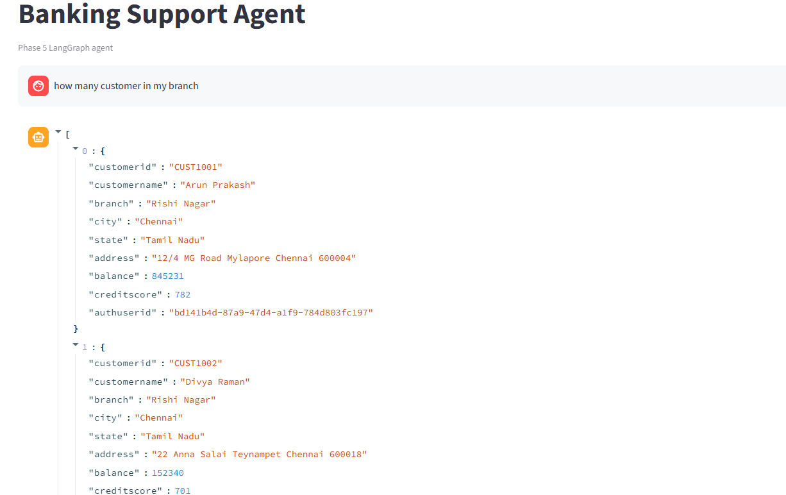
RAG retrieval:


Calculator: Gets formula from RAG, Search Api and then return values to Calculator to get final results


Search API :

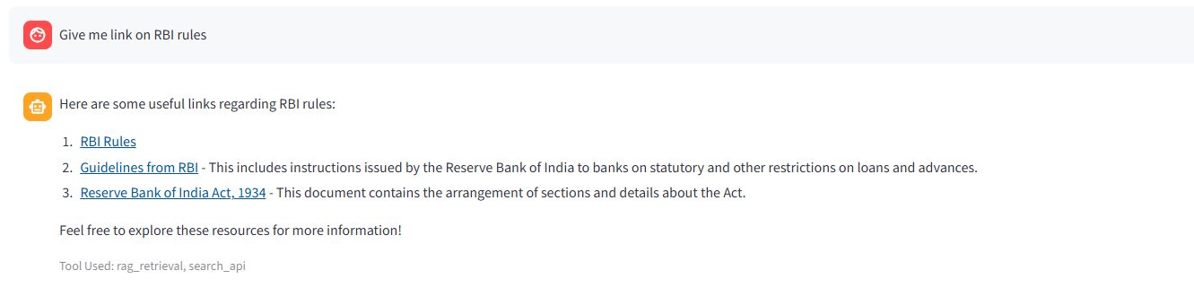

SAFEGAURDS:
- Supabase login required before using the app.
- Role-based access control for customer, manager, support, risk, and admin.
- Supabase RLS enforcement for real data access using the logged-in user JWT.
- Customer self-access only for balance, loans, and transactions.
- Manager branch-only access through RLS.
- Support add/delete blocked.
- Support update scope limited to contact/profile-style fields only.
- Admin-only add/delete path.
- Unauthorized access denial when role or profile context is missing.
- No direct money-transfer tool or transactional execution tool exists.
- Protected data queries bypass generic tool routing and use authenticated Supabase reads directly.
- Role normalization so variant labels like branch manager map safely to the expected role.
- RAG-first retrieval for internal banking knowledge.
- Internet search fallback when RAG is empty, weak, or irrelevant.
- Comparison queries use both RAG and search.Calculator expression validation before execution.
- Malformed calculator expressions are skipped instead of crashing the app.
- Prompt-based role and tool boundaries in prompts/phase5/system_prompt.txt.
- Customer-friendly final response generation so raw chunks/tool dumps are reduced.
- Source display in UI for retrieved knowledge.
- Tool-used display in UI for transparency.
- Confidence score display for RAG retrieval output.

